Currency Conversion table upload
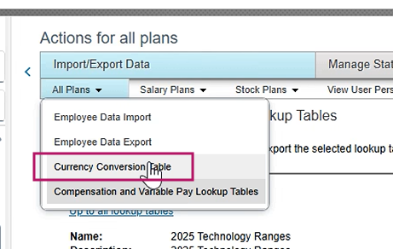

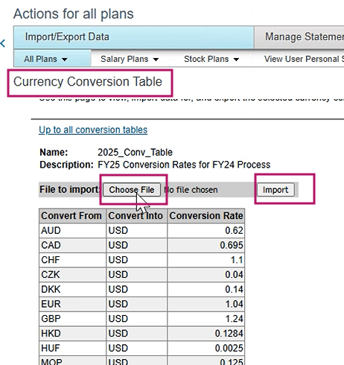

Variable Pay Load (FX)
The same currency table is loaded in the Variable Pay look up table except the USD values
